Laboratory 1 of Electrotechnics and Electrical Machines

Antohi Andi Ionel, Navigation, group 211C

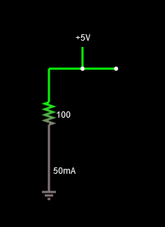

|  |  |  |  |
| --- | --- | --- | --- |
| Order | Resistor R (Ω) | Direct current. I (mA) | Voltage U (V) |
| 1 | 110 Ω | 45.455 mA | 5 V |
| 2 | 57 Ω | 87.719 mA | 5 V |
| 3 | 30 Ω | 166.667 mA | 5 V |
| 4 | 213 Ω | 23.474 mA | 5 V |
| 5 | 270 Ω | 18.519 mA | 5 V |
| 6 | 175 Ω | 28.571 mA | 5 V |
| 7 | 256 Ω | 19.531 mA | 5 V |
| 8 | 671 Ω | 7.452 mA | 5 V |
| 9 | 732 Ω | 6.831 mA | 5 V |
| 10 | 868 Ω | 5.76 mA | 5 V |